Festa di San Sebastiano
*This Celebration is open to family and friends who wish to celebrate La Festa di San Sebastiano!

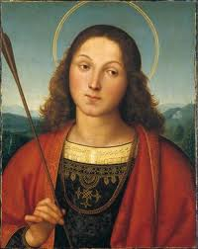

Join us for the Celebration of the “La Festa di San Sebastiano” – Patron Saint of Pettoranello, scheduled for Saturday, January 26, 2013. This event is sponsored by the Princeton Italian-American Sportsmen’s Club in partnership with the Princeton/Pettoranello Sister City Foundation.

A Mass will be celebrated at 5:30 pm at St. Paul’s Church, located on Nassau Street, Princeton, NJ. Following the mass, the second annual dinner/dance celebrating La Festa di San Sebastiano will be held at the Sportsmen’s Club, located at 8 Founders Lane, Princeton, NJ beginning at 7:00 pm.

Music by TN-Tertainment, LLC – John Rossi, DJ
Food catered by D’Angelo’s Italian Market/Café

Cost $35 per person

** Admission price includes food, soft drinks, wine, beer and entertainment **
Cash Bar for all other drinks

To attend this celebration, please return the bottom portion of this form, along with your check no later than January 18, 2013

Note: Entrance fee must be paid in advance.

Payment will not be accepted at the door.

If you have any questions call Ellie at 609-921-7911 or Michelle Toto at 609-504-6136

****************************************************************************************************************************

NAME _________________________________________________Tel.____________________________
(Print Name) (In case we need to contact you)

NUMBER ATTENDING ________ @ $35.00/ea $______________

MAKE CHECKS PAYABLE TO: Princeton Italian-American Sportsmen’s Club (PIASC)

Return to:
L. Pirone
18 Francis Drive
Hillsborough, NJ 08844

